**COMSATS UNIVERSITY ISLAMABAD**

**HUMAN COMPUTER INTERACTION**

**ASSIGNMENT # 03**

**Kulsoom Khurshid (SP20-BCS-044)**

**You all have access to CUOnline. Choose any one aspect of it, such as course registration or viewing your marks in a course. It shouldn’t be too simple. Do Heuristic evaluation of CUOnline. You can choose any of the lists of heuristics provided to you.**

For a heuristic evaluation of the "View Marks for a course" feature of CUOnline, we will use Nielsen's 10 Usability Heuristics. These heuristics are widely used in the field of usability engineering.

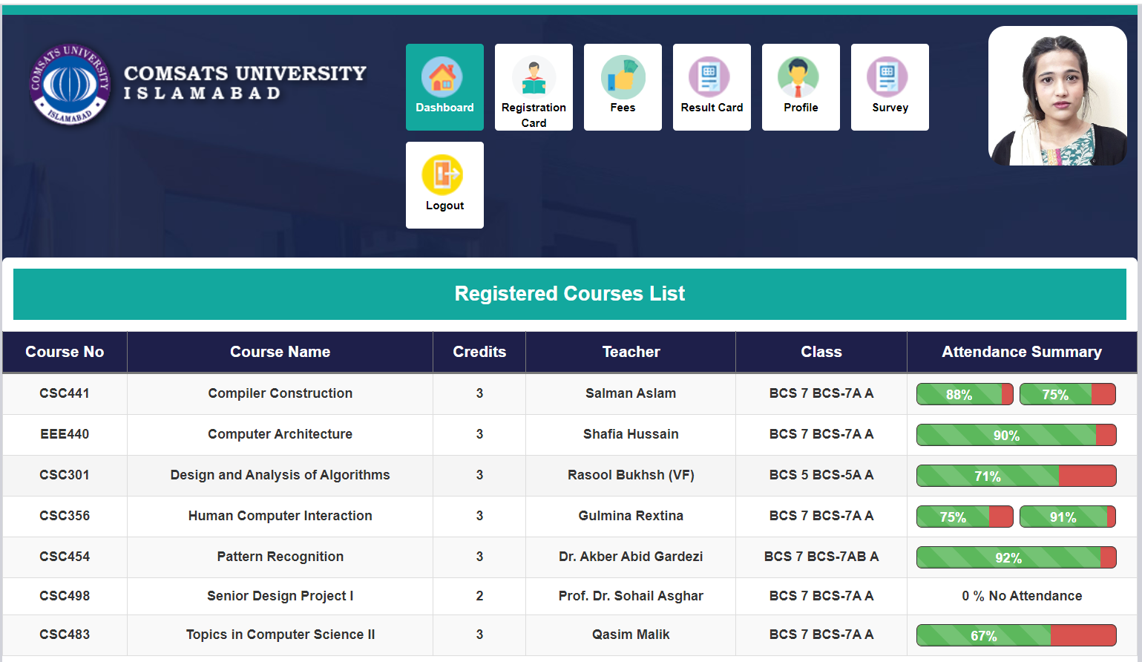

**Figure 1: Dashboard**

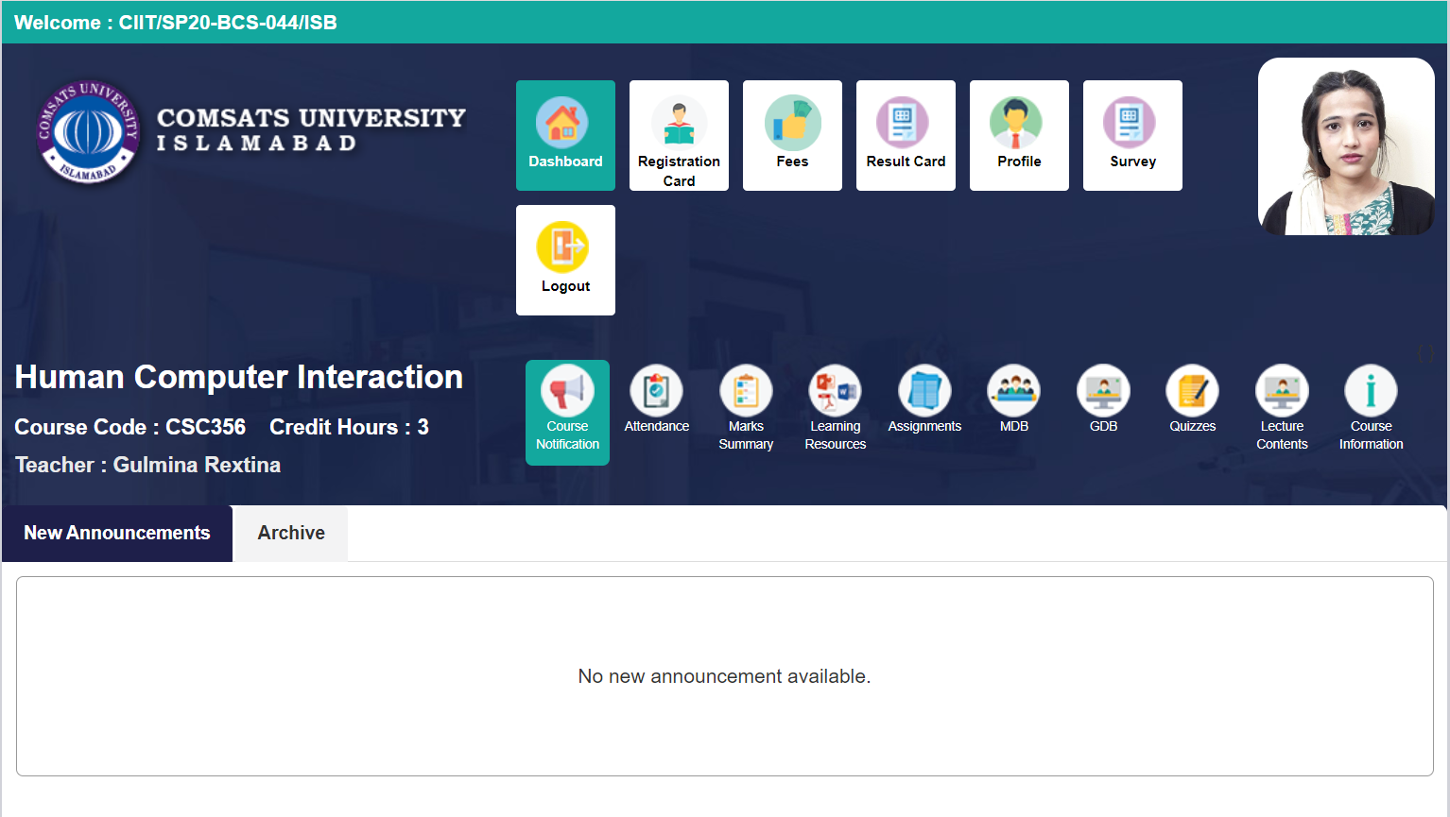

**Figure 2: Course details**

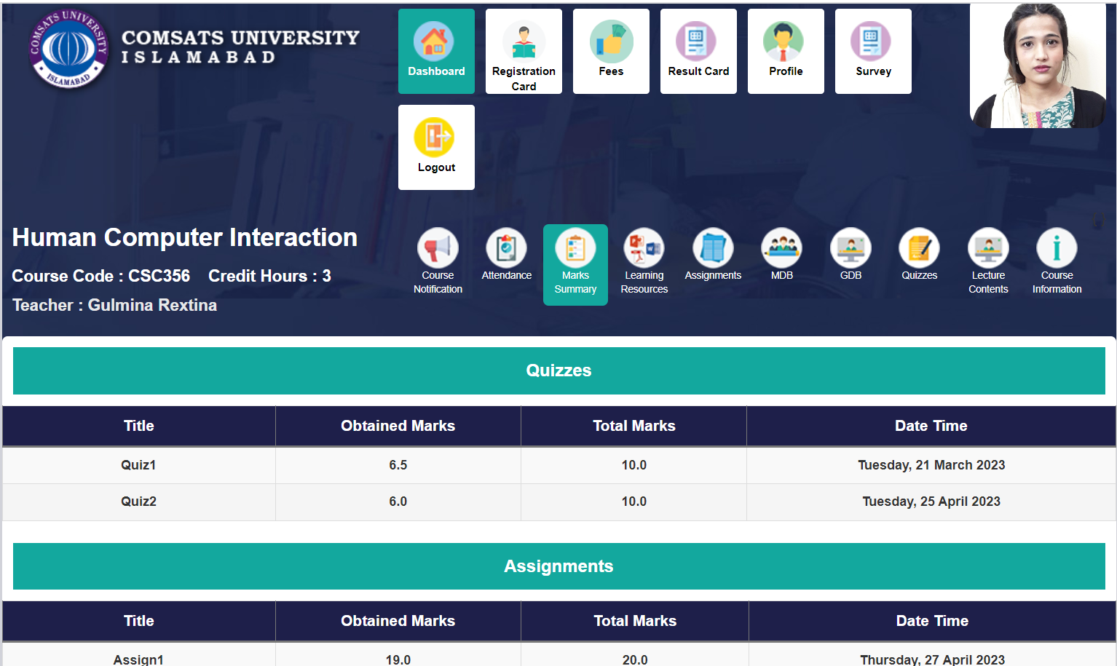

**Figure 3: Course Marks**

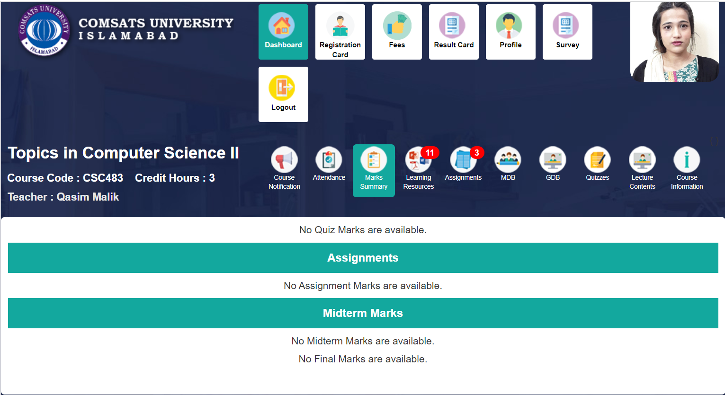

**Figure 4: Course Marks**

**Visibility of system status:**

CUOnline should provide feedback to users about their actions, system response, and current status during view marks process.

* The system does provide the feedback in the form of marks, if the marks are not uploaded yet it displays a message to the user that marks are not available as shown in figure 4.
* No feedback and comments from teachers or instructors for each course component. It would be much better to display feedback alongside the marks as it allows students to understand their performance better and learn from the provided guidance.

**Match between system and the real world:**

The language and terminology used in CUOnline should align with the concepts and vocabulary familiar to students. It should not use technical jargon or confusing terms that are not commonly understood.

* The icons and the language is familiar to all students.

**User control and freedom:**

The navigation within the CUI Online Portal should be intuitive and easy to understand. Users should be able to locate the course and access the "Marks summary" option within each course without confusion.

* The users can easily navigate to any course and view the marks summary in just 2-3 clicks.

**Consistency and standards:**

Ensure that the design elements, such as buttons, icons, and layout, are consistent throughout the portal. This consistency helps users recognize and understand the interface elements, making it easier for them to find and access the "Marks Summary" option.

* Considering the CUI student portal, the icons are consistent means the same icon is used for marks in all courses.

**Error prevention:**

Implement appropriate error handling mechanisms to handle any errors or issues that may occur while retrieving the marks. Clear error messages should be displayed, providing guidance on how to resolve the problem or seek assistance.

* As such no errors occur while viewing the marks for a course, but if any error occurs due to internet issues or for some other reason there is no proper error prevention technique has been followed. So this is one of the short comings of the system.

**Recognition rather than recall:**

CUOnline should minimize the cognitive load on students by presenting information and options clearly. It should avoid relying on users' memory and provide relevant cues, prompts, and reminders during the view marks process.

* The user does not has to memorize the steps to view the marks, the icons itself help the user to navigate through the process.
* The icons for attendance and marks summary is similar so user might select the wrong option if selected in hurry.

**Flexibility and efficiency of use:**

CUOnline should cater to both novice and experienced users. It should offer shortcuts, advanced features, or customization options for students who are familiar with the system and want to navigate through the view marks process quickly.

* The portal is designed responsively to provide an optimal viewing experience across different devices and screen sizes. This allows students to access their marks conveniently, whether they are using a computer, tablet, or mobile device.
* The CUI portal provides access to multiple courses, the user can easily select the desired course. The course selection process is clear and well-labeled, enabling users to quickly locate and choose the course they want to view marks for.

**Aesthetic and minimalist design:**

CUOnline should maintain a clean and intuitive interface, without unnecessary clutter or visual distractions. It should prioritize essential course information, marks summary, and relevant actions, ensuring a focused and efficient user experience.

* The design is very minimalist as it uses 2 basic colors that are very much subtle. It does not have extra information hence making the use way easier.
* Once the user selects the "Marks summary" option for a specific course, the marks for each course component (assignments, quizzes, mid-term, final) should be displayed clearly. Users should be able to view their marks for each component at a glance.

**Help users recognize, diagnose, and recover from errors:**

CUOnline should provide clear error messages that precisely explain the issue and suggest appropriate solutions. It should guide users on how to rectify errors.

**Help and documentation:**

CUOnline should offer easily accessible help and documentation resources within the course. It should include FAQs, video tutorials, or a knowledge base to assist users in understanding the overall process and resolving common issues.

**Conclusion:**

Based on this heuristic evaluation, CUOnline should focus on improving feedback and system status visibility, enhancing error prevention techniques, and providing better guidance for error recovery. Additionally, incorporating helpful documentation would further enhance the user experience during view marks process.